**Using Quantile Mapping and Random Forest for bias-correction of high-resolution reanalysis data and CMIP6 climate projections over Iran**

***International Journal of Climatology***

**Maryam Raeesi, Ali Asghar Zolfaghari[1], Seyed Hasan Kaboli, Mohammad Rahimi, Joris de Vente, Joris PC Eekhout**

|  |  |  |
| --- | --- | --- |
| **(a)**  **(b)** |  | |
| **(c)** | **Figure S1 Mean values of annual precipitation for each CMIP6 model in three periods of time using RF method; Near-future from 2023-2047 (a), Mid-future from 2048-2073 (b), and Far-future from 2074-2100 (c) under SSP2-4.5 scenario** | |
| **(d)** | | **(e)** | |
| **(f)** | | **Figure S2 Mean values of annual precipitation for each CMIP6 model in three periods of time using RF method; Near-future from 2023-2047 (d), Mid-future from 2048-2073 (e), and Far-future from 2074-2100 (f) under SSP3-7.0 scenario** | |

|  |  |
| --- | --- |
| **(g)** | **(h)** |
| **(i)** | **Figure S3 Mean values of annual precipitation for each CMIP6 model in three periods of time using RF method; Near-future from 2023-2047 (g), Mid-future from 2048-2073 (h), and Far-future from 2074-2100 (i) under SSP5-8.5 scenario** |

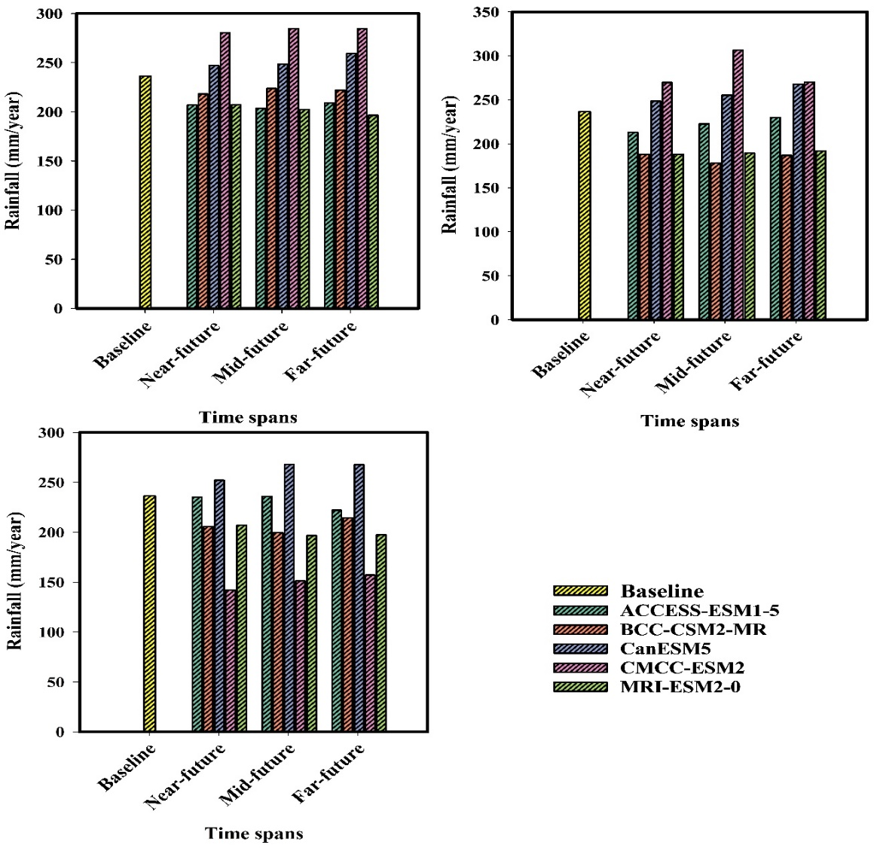

**Figure S4 Visualization of annual average precipitation values in four time periods: baseline (1990-2020), near-future (2023-2047), mid-future (2048-2073), and far-future (2074-2100) under SSP2-4.5 (a), SSP3-7.0 (b), and SSP5-8.5 (c)**

|  |  |
| --- | --- |
| **a** | **b** |
| **c** | **d** |
| **e** | |

**Figure S5 Total area changes (%) in case of annual precipitation in Iran during the Baseline period (1990–2020) and Future mean projected values based on the (a) ACCESS-ESM1-5, (b) BCC-CSM2-MR, (c) CanESM5, (d) CMCC-ESM2, and (e) MRI-ESM2-0 under three scenarios**

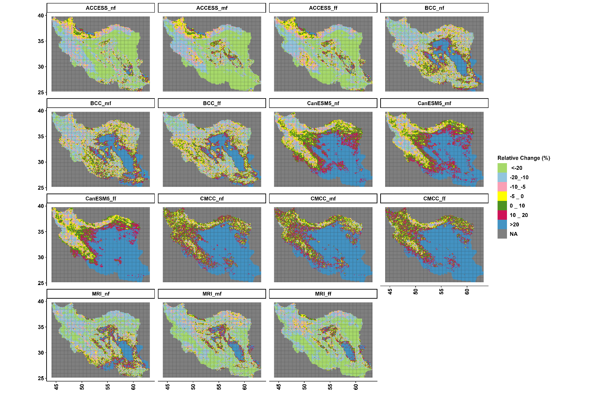

**Figure S6 Relative Changes (RC) obtained from RF model in annual rainfall (%) based on SSP2-4.5; each panel demonstrate an individual CMIP6 outputs in three future time spans: “nf”, “mf”, and “ff” refer to Near-future (2023-2047), Mid-future (2048-2073), and Far-future (2074-2100), respectively**

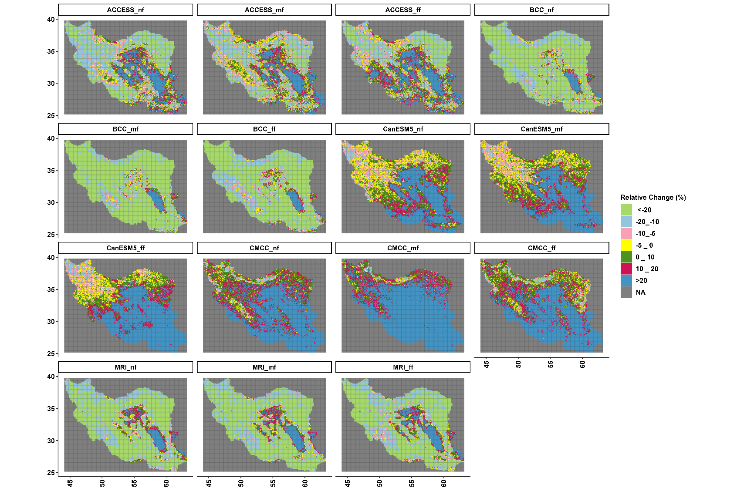

**Figure S7 Relative Changes (RC) obtained from RF model in annual rainfall (%) based on SSP3-7.0; each panel demonstrate an individual CMIP6 outputs in three future time spans: “nf”, “mf”, and “ff” refer to Near-future (2023-2047), Mid-future (2048-2073), and Far-future (2074-2100), respectively.**

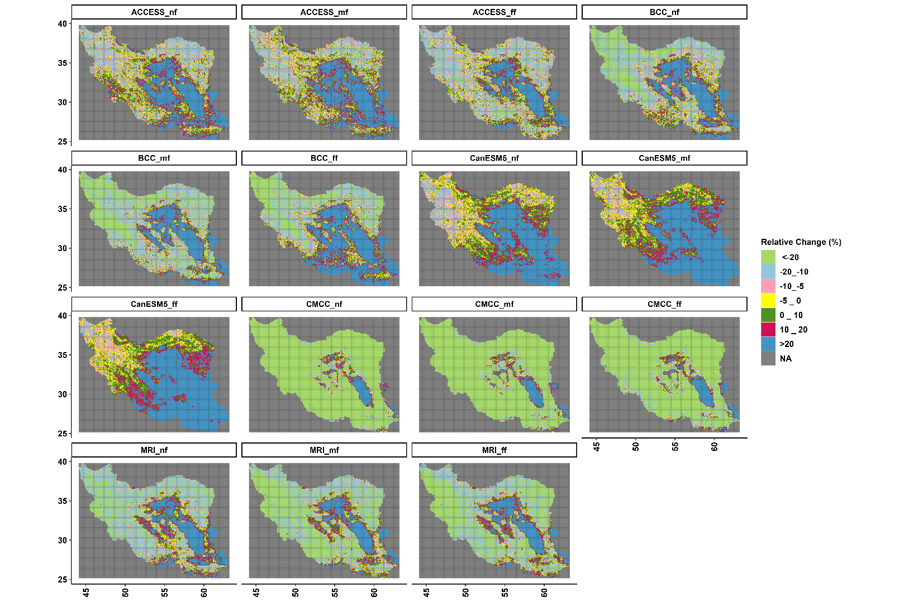

**Figure S8 Relative Changes (RC) obtained from RF model in annual rainfall (%) based on SSP5-8.5; each panel demonstrate an individual CMIP6 outputs in three future time spans: “nf”, “mf”, and “ff” refer to Near-future (2023-2047), Mid-future (2048-2073), and Far-future (2074-2100), respectively.**

1. **Corresponding author,** [**azolfaghari@semnan.ac.ir**](mailto:azolfaghari@semnan.ac.ir)**, Faculty of Desert studies, University of Semnan, Iran**